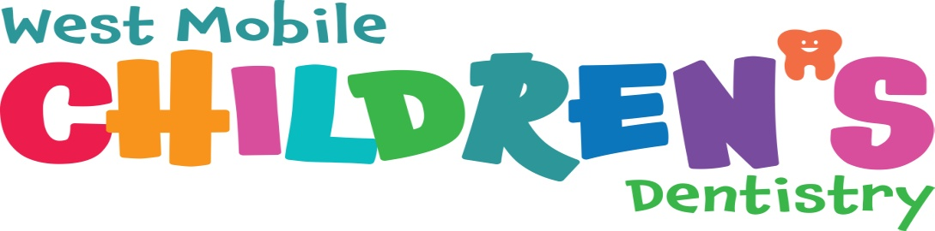

Internet and Social Media Consent

Patient’s Name:_________________________________________________________________

Name of Person Signing this Form:_________________________________________________

Relationship to Patient:___________________________________________________________

At West Mobile Children’s Dentistry, we are proud of our patients and would love the opportunity to take pictures and share them on the Internet and Social Media websites such as Facebook and Instagram. Sharing pictures on these sites is a positive and great way for other children to see dentist as a fun and safe environment.

Please select on the following;

___ I do not consent to photographs being shared on the Internet and social Media sites.

___ I give full consent to the use of photographs on the Internet and Social Media sites

Signature of Parent/Guardian: _____________________________________________________

Date: ___________________________________